Chapter 2, Solution 28 Design a problem, using Fig. 2.92, to help other students better understand series and parallel circuits.

Although there is no correct way to work this problem, this is an example based on the same kind of problem asked in the third edition.

Problem

Find v₁, v₂, and v₃ in the circuit in Fig. 2.92.

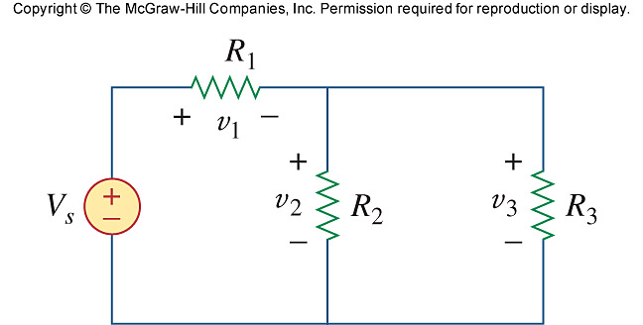

Solution

We first combine the two resistors in parallel

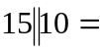 6 Ω

We now apply voltage division,

v₁ = 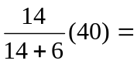 28 V

v₂ = v₃ = 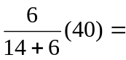 12 V

Hence, v₁ = 28 V, v₂ = 12 V, v_{s} = 12 V

